Chicago Transit Authority

Number SB19-0207
Effective May 25, 2019
Copies to Bus Distribution List
Supersedes
Activity code 11094
Scheduling & Service Planning
Bus Schedule Bulletin

Valant Wright-Scurlock, Senior Manager May 17, 2019
74th Garage

To begin Saturday seasonal service to 63rd Street Beach on route #63-63rd St., operate two (2) extras on a special beach shuttle route on four (4) dates during the Spring 2019 pick.

NOTE: Please remind all operators that Fares Bulletin F19-19 will be in effect on these same four Saturdays. Operators must record all rides by pressing key 8 (free rides) on farebox keyboards when operating beach shuttle trips.

RE: #63-63rd – Saturday Seasonal Beach Shuttle Service – Spring 2019 Pick

SATURDAY
May 25
June 1
June 8
June 15

Operate the following 2 extras on the above dates ONLY:

 |  |  | Pull-out
Duty | Report | Time | To: | Pay
6381 | 0807 | 0822+ | #63 @ 63 Ash | 9h02
6382 | 1204 | 1219 | #63 @ 63 Ash | 9h06

Operational notes are attached.
Training map is attached.
Duty paddles are attached.

Please contact Theodore Coulson, Senior Manager, Bus Scheduling Design & Development, at (312) 681-4186 with any immediate concerns regarding the implementation of this bulletin.

Please forward comments, including ridership and cost analysis data to:
Jacob Connor, Special Events Coordinator, Service Planning
Scheduling & Service Planning Dept., 10th Floor / 567 W. Lake St. / Chicago, IL 60661-1465

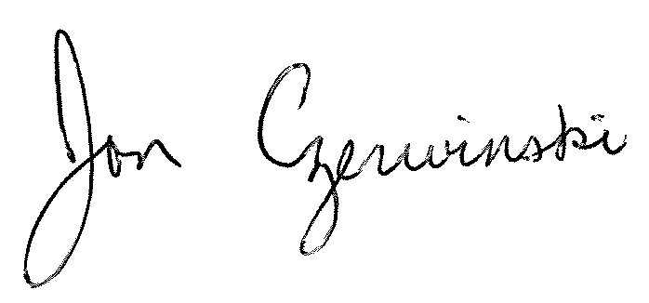
Jon Czerwinski
Director
Scheduling

Operational Notes: #63 Beach Shuttle Service

- Buses pulling in or out of the garage will operate as a regular route #63 to/from 63rd Street Beach.
- When operating shuttle trips, set AVAS to route #63 and select “Beach Shuttle” trip pattern.
- No fares are collected on any shuttle trip that begins/ends at 63rd/Stony Island and 63rd Street Beach.
- On eastbound trips from the garage, do not collect fares after 63rd/Blackstone.
- On westbound trips to the garage, do not collect fares at the beach. After leaving the beach, resume normal fare collection.

Eastbound operation (to beach):

From 63rd & Stony Island layover point, shuttles will operate via:

- South on Stony Island to 64th (turn right)
- West on 64th to Blackstone (turn right)
- North on Blackstone to 63rd (turn right)
- East on 63rd, which transitions into eastbound Hayes, to Richards (veer right)
- South on Richards to Marquette (turn left)
- East on Marquette to Lake Shore (turn left)
- North on Lake Shore to Hayes (turn left)

Westbound operation (from beach):

From Hayes Dr & Lake Shore Drive bus stop, shuttles will operate via:

- West on Hayes, which transitions into westbound 63rd , to Stony Island (turn left)
- Take recovery time southbound on Stony Island at 63rd, farside.

